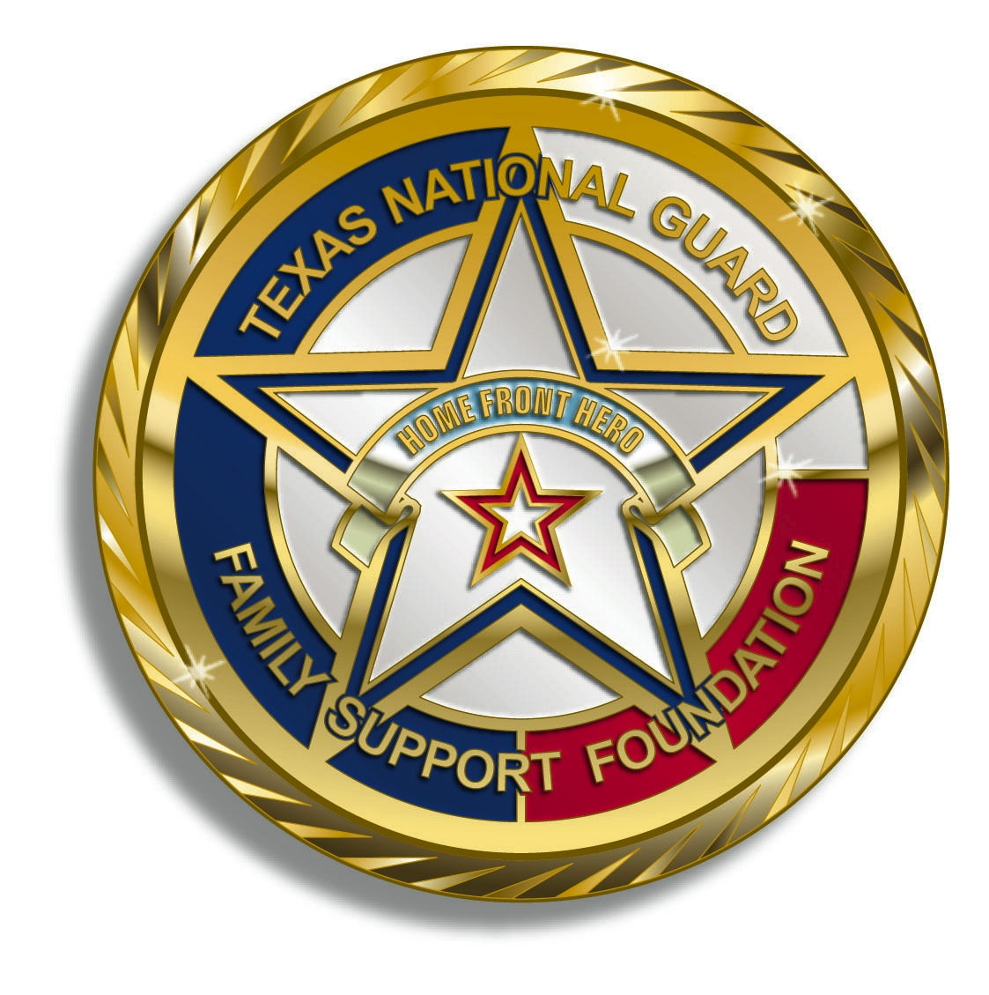

Texas National Guard Family Support Foundation
2008 TH Jones Mill Way
Salado, TX 76571
512-535-0053

Limited Fundraising Group Guidelines

The Texas National Guard Family Support Foundation (Foundation) provides limited fundraising opportunities for unit Family Readiness Groups (FRGs). This provides FRGs an alternative to fundraise above the annual cap allowed for unit FRGs.
Individuals representing unit FRGs apply to become a Foundation “Agent” of a Limited Fundraising Group (LFG). The Agents raise funds for the Foundation in accordance with guidelines, ensuring that the funds so raised are designated for their unit. The Foundation allocates designated funds into unit accounts that the Foundation administers, giving the Agents the ability to raise unlimited funds that can be used for the benefit of the designated unit. As the Foundation is a 501(c)(3), all donations to the Foundation are tax deductible. The Foundation will send donation letters and tax-related documentation to all donors. Twenty percent (20%) of all donations will be retained by the Foundation to cover administrative costs and to fund Foundation programs.
Limited Fundraising Agreement
Each LFG must execute a Limited Fundraising Agreement signed by the Foundation representative and an LFG Campaign Manager. After receiving Foundation approval and a copy of the LFA, all Agents may begin fundraising activities. The LFA is valid only for a calendar year, but may be extended.
Campaign Managers
Each LFG must have a Campaign Manager. Any spouse or member of the unit can be a Campaign Manager since s/he are soliciting donations for the Foundation and not the FRG. Service members serving as Campaign Manager may not solicit funds during duty hours or in uniform. The Campaign Manager will serve as liaison between the LFG and the Foundation.
Campaign Agents
An LFG may have multiple Campaign Agents. The Campaign Manager is by position also a Campaign Agent. Each Campaign Agent must sign a Fundraising Directives document that is then forwarded to the Foundation.
Fundraising Directive
All Campaign Agents must sign and return to the Foundation a Fundraising Directive that outlines permissible and non-permissible fundraising activities.
Donation Documentation
LFGs will handle and document all donations in accordance with the Fundraising Directive.
Requesting LFG funds
Only Campaign Managers may request funds. The preferred method of distributing LFG funds is to purchase items directly from a vendor. If necessary, the Foundation may reimburse someone with the approval of the Campaign Manager and a receipt.

Texas National Guard Family Support Foundation
2008 TH Jones Mill Way
Salado, TX 76571
512-535-0053

Limited Fundraising Agreement

This Limited Fundraising Agreement is entered into by the Texas National Guard Family Support Foundation (“Foundation”) and TXNG FSF - __________________ (unit) FRG, a Limited Fundraising Group (“LFG”) for the calendar year 2021.
The LFG is permitted to conduct fundraising for the Foundation in accordance with the terms of the attached Fundraising Guidelines and Fundraising Directive.
The following are the key personnel of the LFG:
Campaign Manager: ____________________________________________________
Phone Number: ____________________________________________________
Email: ____________________________________________________

Agent: ____________________________________________________
Phone Number: ____________________________________________________
Email: ____________________________________________________
Authorized Signatories:
___________________________________ _________________________________
Campaign Manager Foundation
___________________________________ _________________________________
Printed Name Date Printed Name Date

Texas National Guard Family Support Foundation
2008 TH Jones Mill Way
Salado, TX 76571
512-535-0053

Fundraising Directive

- All donations are solicited on behalf of the Texas National Guard Family Support Foundation.
- Donations may be mailed to the Foundation office by the donor or by the Agent. Ensure that the LFG information is on the memo line of the check.
- Agents should retain a photo copy of all checks prior to sending them to the Foundation. All check submissions by the Agent must include the name and address of the donor (the information on the check will suffice if it is correct).
- Donations may be made online, but the LFG information must be included in the memo/remarks section.
- All fundraising material must be approved by the Foundation and include basic Foundation information and disclaimers.
- All raffles must be approved by the Foundation.
- No fundraising may be done in uniform.
- No fundraising is being done for the National Guard; fundraising is for the Foundation to support activities benefiting Guardsmen and their families.

I understand and agree to comply with the fundraising directives outlined above.

Signature

Printed Name Date

LFG Name

